**Lab 10 EAI**

Create an EAI application related to an Auction Item.

Use Case:

Customer broadcasts [over RabbitMQ] an auction Item. [Use Producer Solution from Lab 9]

You need to build a Spring Integration application that consumes the broadcasted auction items.

Upon receipt of an Item, EAI application generates an Auction ID for the Item [***use a Transformer***].

The Auction ID is the combination of the Item Name AND version number.

The Item is then routed [***use a Router***] based on the Item price to one of two JMS outbound adapters.

If the price is Greater than $20.00, it is routed to the “high price” JMS adapter.

Otherwise it is routed to the “moderate price” adapter.

There should also be two JMS listeners [can be included in the EAI application],

one for High Price and one for Moderate Price.

Here is example output based on a successful run of the process:

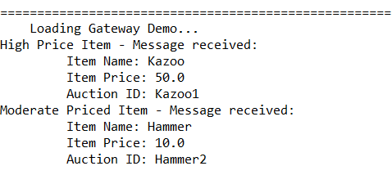

Here is Bus Flow:

